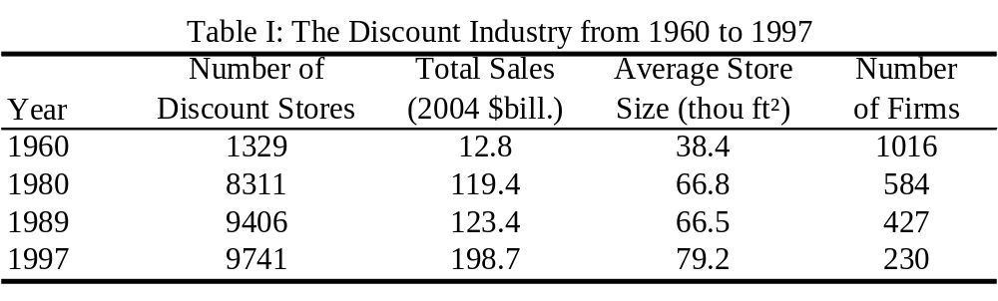
Source: various issues of Discount Merchandiser. The numbers include only traditional discount stores. Wholesale clubs, super-centers, and special retailing stores are excluded.

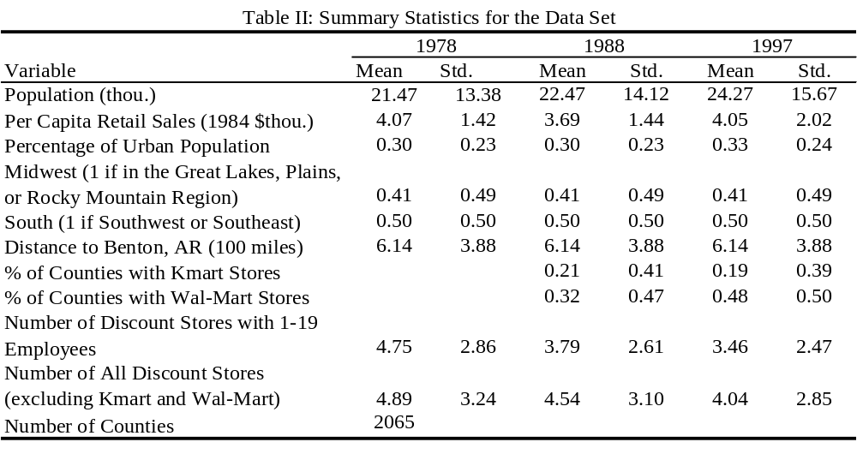
Source: the population is from the website of the Missouri State Census Data Center. Retail sales are from the 1977, 1987, and 1997 Economic Census, respectively. The percentage of urban population is from the 1980, 1990, and 2000 decennial census, respectively. Region dummies are defined according to the 1990 census. The numbers of Kmart and Wal-Mart stores are from the annual reference “Directory of Discount Stores” by Chain Store Guide, Business Guides, Inc., New York. The numbers of small discount stores and all other discount stores are from various years of the County Business Patterns.

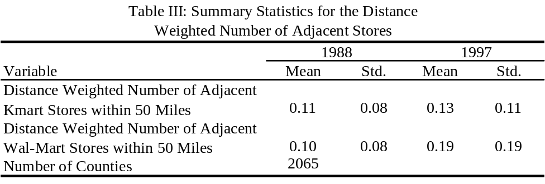
Source: “Directory of Discount Department Stores” by Chain Store Guide, Business Guides, Inc., New York.

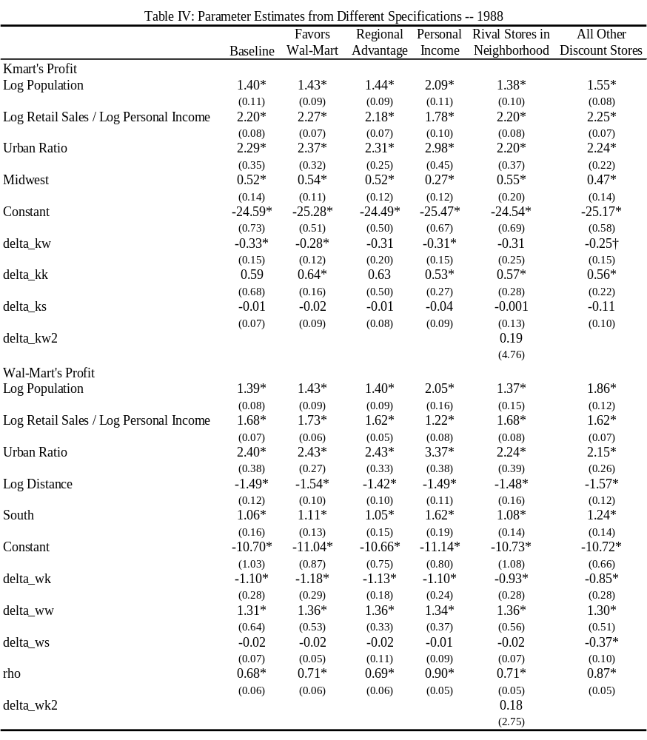
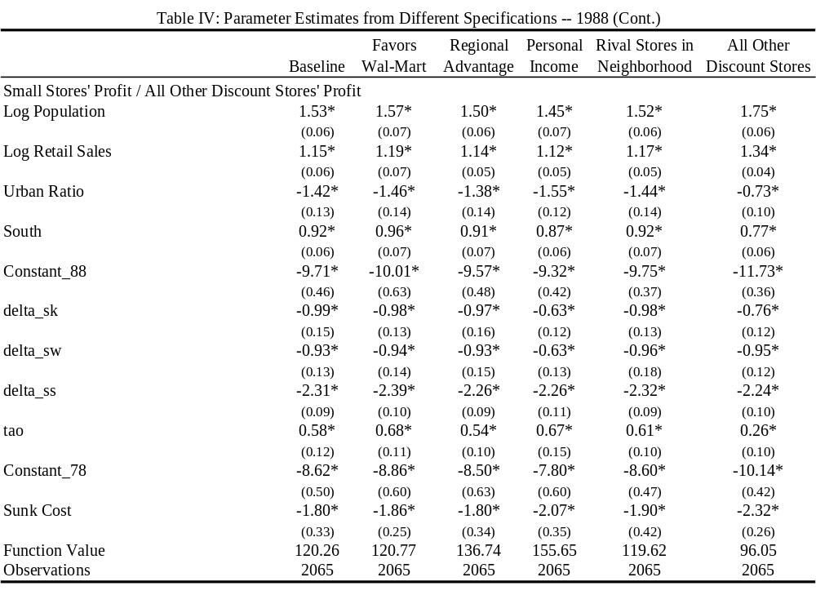
Note: * denotes significance at the 5% confidence level, and † denotes significance at the 10% confidence level. Standard errors are in parentheses. Midwest and South are regional dummies, with the Great Lakes region, the Plains region, and the Rocky Mountain region grouped as the “Midwest”, the Southwest region and the Southeast region grouped as the “South”. delta_kw, delta_ks, delta_wk, delta_ws, delta_sk, delta_sw, and delta_ss denote the competition effect, while delta_kk and delta_ww denote the chain effect. “k” stands for Kmart, and “w” stands for Wal-Mart. “s” stands for small stores in the first five columns, and all discount stores (except Kmart and Wal-Mart stores) in the last column.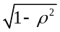measures the importance of the market-level profit shocks.
In the first three columns, the parameters are estimated using the equilibrium most profitable for Kmart, the equilibrium most profitable for Wal-Mart, and the equilibrium that grants Kmart advantage in the Midwest region and Wal-Mart advantage in the South, respectively. In the last three columns, the parameters are estimated using the equilibrium that is most favorable for Kmart. In the fourth column, log of personal income per capita is used in Kmart’s and Wal-Mart’s profit function. In column five, the existence of rival stores in neighboring markets matters. Column six estimates the model using Kmart, Wal-Mart, and all other discount stores, not just small stores.

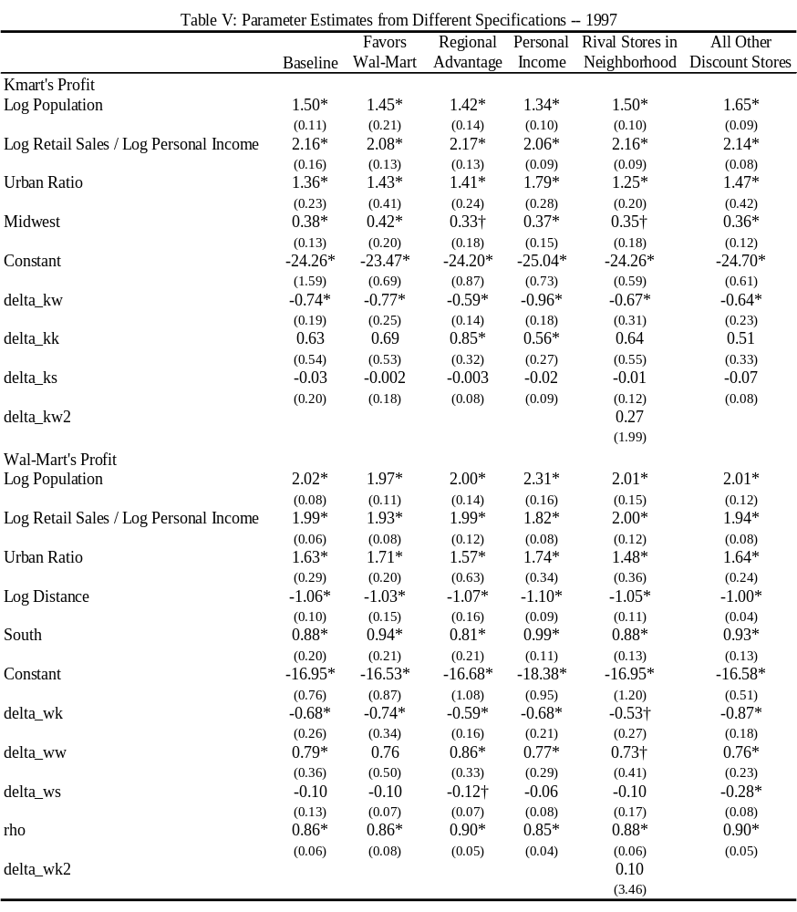
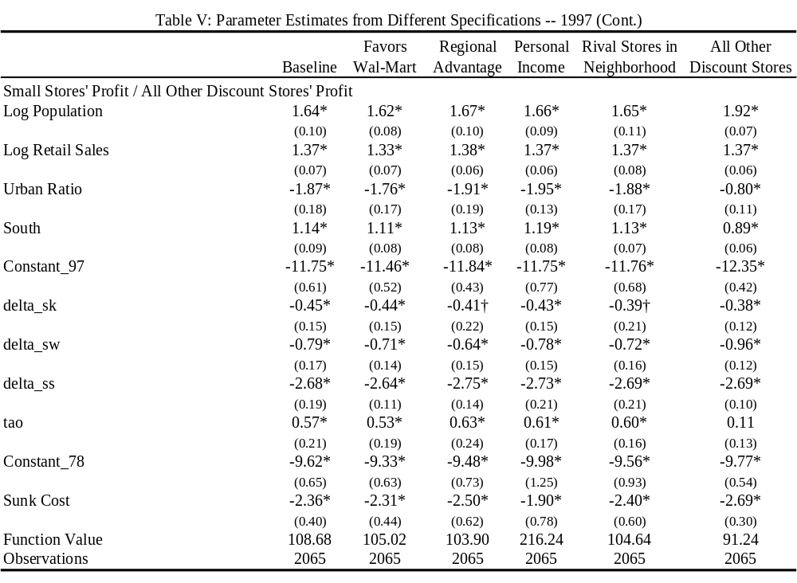
Note: * denotes significance at the 5% confidence level, and † denotes significance at the 10% confidence level. Standard errors are in parentheses. See Table IV for the explanation of the variables and the different specifications for each column.

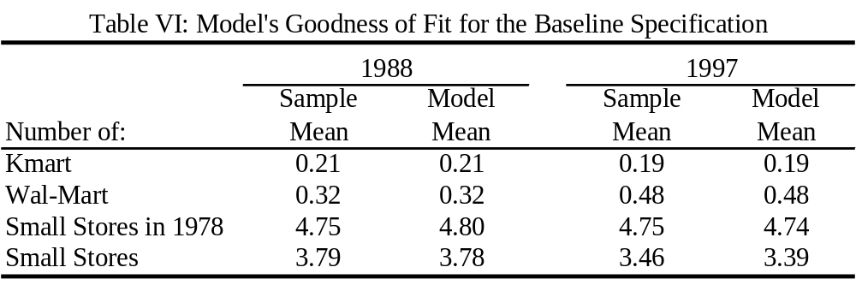

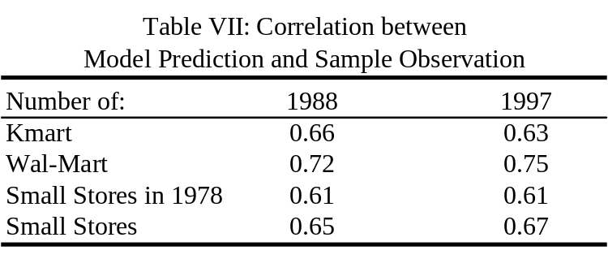

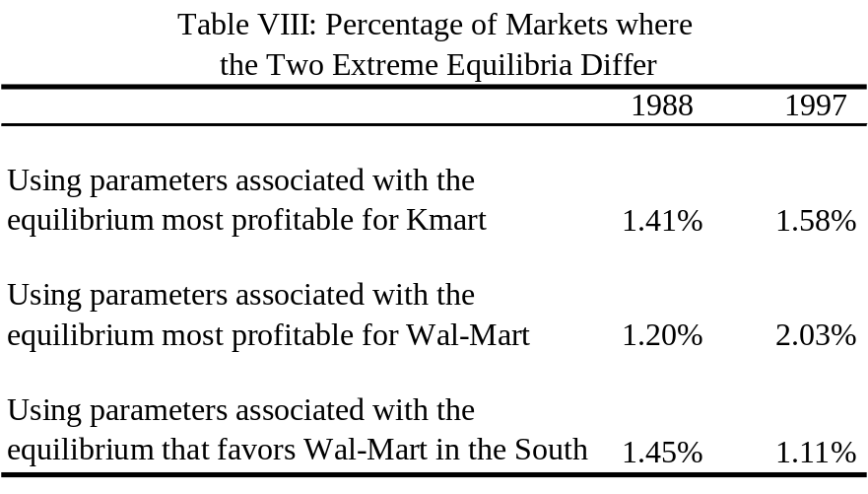
Note: for each of these exercises, I solve the two extreme equilibria (the one most profitable for Kmart and the one most profitable for Wal-Mart) evaluated at the same set of parameter values, compute their difference, and average over 300 simulations.

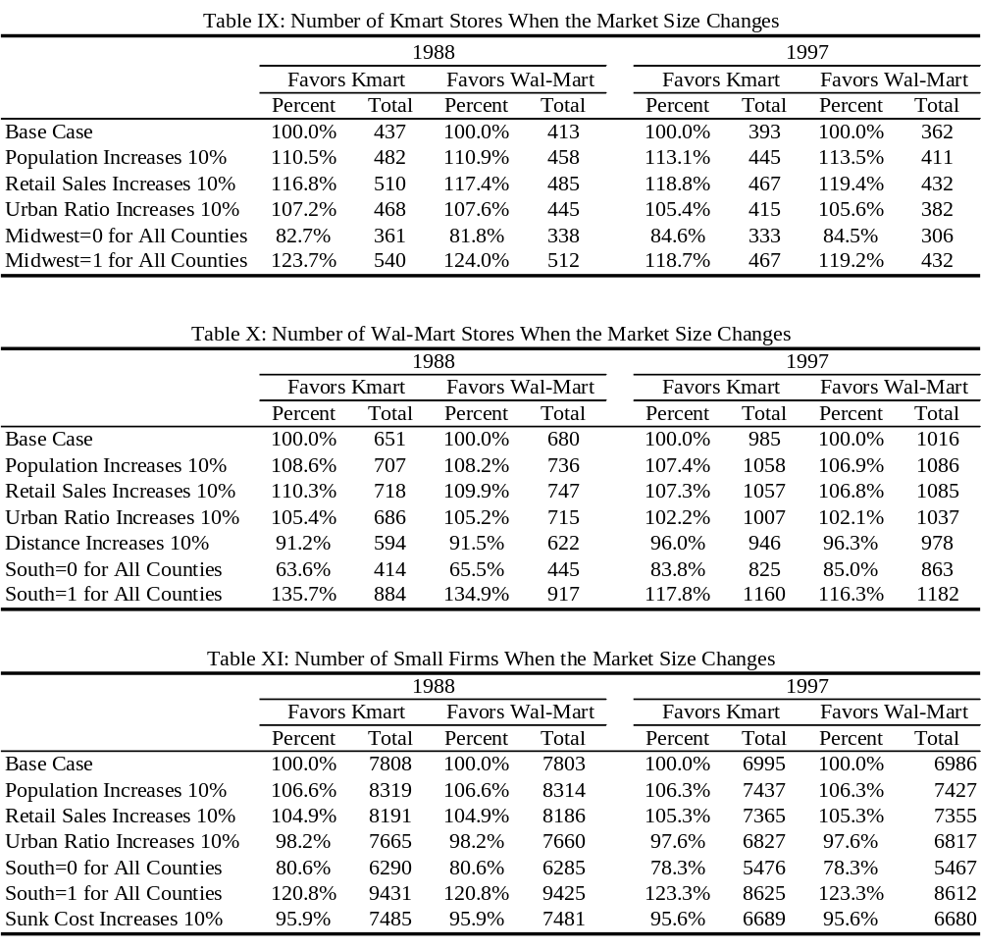
Note: for each of the simulation exercises in all three tables, I fix other firms’ profits and change only the profit of the target firm in accordance with the change in the market size. I re-solve the entire game to obtain the new equilibrium numbers of firms. Columns labeled with “Favors Kmart” use the equilibrium most profitable for Kmart, and columns labeled with “Favors Wal-Mart” use the equilibrium most profitable for Wal-Mart. For example, in the second row of Table 6 (A), I increase Kmart’s profit according to a ten percent increase in population while holding Wal-Mart’s and small firms’ profit the same as before. Using this new set of profits, and the equilibrium that favors Kmart most, the number of Kmart stores is 10.5% higher than in the base case in 1988.

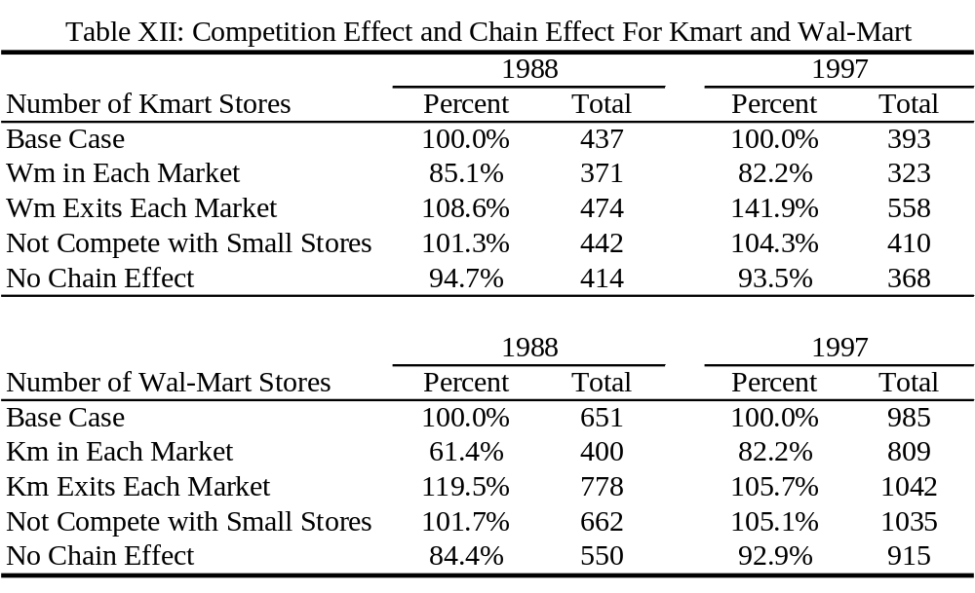
Note: ‘Base Case’ is the number of stores observed in the data. For each exercise, I re-solve the full model under the specified assumptions. For the last two rows of both panels where the counter-factual exercise involves multiple equilibria, I solve the model using the equilibrium that is most profitable for Kmart.

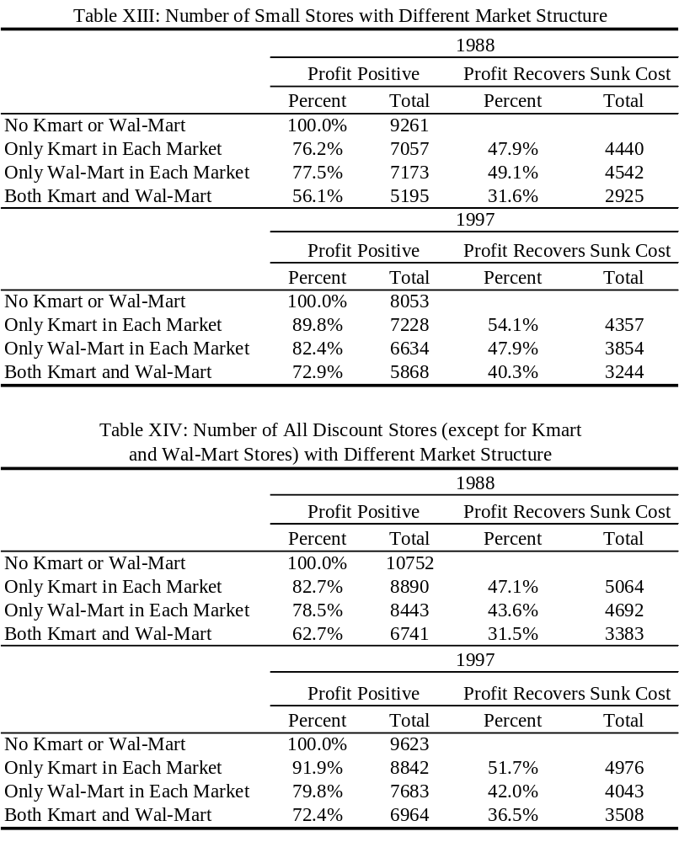
Note: in each exercise, I fix the number of Kmart and Wal-Mart stores as specified and solve for the equilibrium number of small stores in Table XIII, and the number of all other discount stores in Table XIV. If stores have perfect foresight, the columns labeled with “Profit Recovers Sunk Cost” would have been the number of stores that we observe, as they would not have entered in the pre-chain period if their profit after entry could not recover the sunk cost.
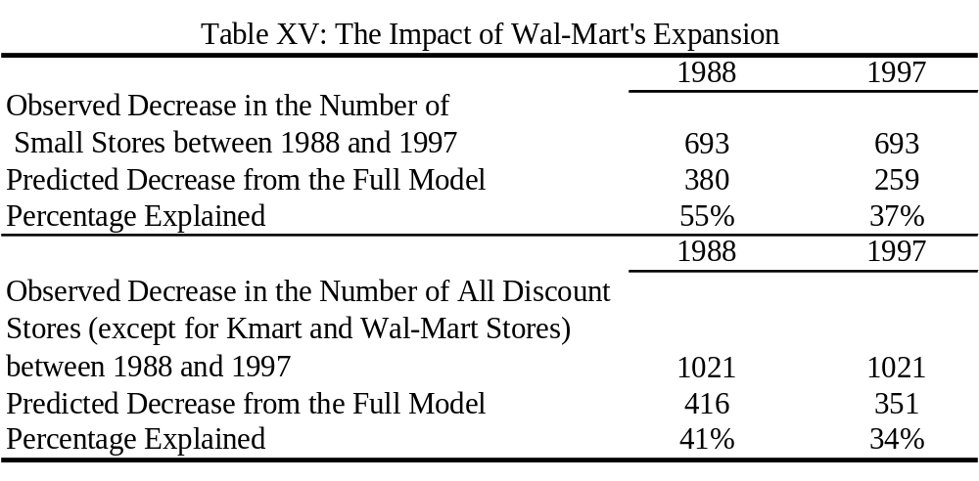
Note: in the top panel, the predicted 380 store exits in 1988 are obtained by simulating the change in the number of small stores using Kmart’s and the small stores’ profit in 1988, but Wal-Mart’s profit in 1997. The column of 1997 uses Kmart’s and small stores’ profit in 1997, but Wal-Mart’s profit in 1988. Similarly for the second panel.

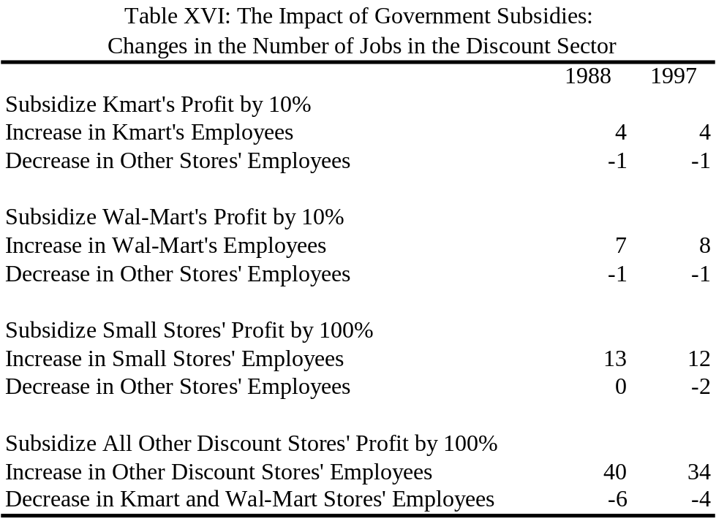
Note: for each of these counter-factual exercises, I incorporate the change in the subsidized firm’s profit as specified, solve for the equilibrium numbers of stores, and obtain the estimated change in employment assuming that a) a Kmart or a Wal-Mart store employs 300 employees, b) a small discount store employs 10 employees, and c) an average discount store employs 25 employees.

